SWDNL Code of Practice – “INSPIRE” Agreement
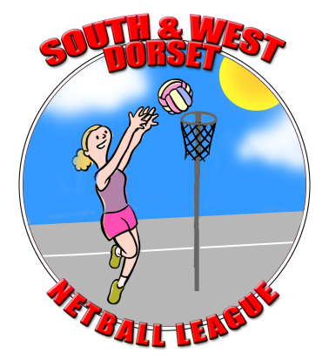

FOR ALL PLAYERS (new players must be signed up)/OFFICIALS/COACHES/VOLUNTEERS/SPECTATORS

SWDNL Ethos
Strive to achieve the highest possible standards of playing, coaching & umpiring; both as an individual and for the League, whilst promoting good sportsmanship – “inspire” a generation.
All league members must realise they play as part of a team/club/league, not as an individual. Actions of players reflect the team/club/league as a whole. As a member we must ensure that we promote positive impressions through our:
- behaviour, both on and off court
- body language
- interaction with other teams, players and umpires
- nurturing the young and leading by example.

Interact with team-mates, coaches, umpires and opponents showing respect
Note to self on why we play netball; for fun, aspirations for the top and always try your best – positive attributes
Support umpires in their interpretation of the rules and officiating of our game; respect their decisions
Positive approach to play on and off the court (includes use of social media); never use bad language or insult opponents, coaches or spectators
Individual awareness of our own personal behaviour and how it may be perceived
Raise a smile; enjoy yourself and help others to enjoy their netball experience by familiarising yourself with the rules of England Netball and play by the spirit of the game
Employ sportsmanship; do not try to gain an unfair advantage over others

Sportsmanship Towards Others
The umpire is there to control; respect their decisions – players, spectators, coaches and volunteers should not try to sway their decision, but need to play to their interpretation of the rules. Smile and acknowledge the umpire's decisions (consider the most appropriate way to clarify understanding of rules, we recommend all teams have a copy of rulebook). Treat the opposition, as we would like to be treated. In light of differences, approach clarification with umpires in the appropriate sequence, through your designated captain.

Disciplinary/ Complaints Policy & Procedures
This relates to all players, spectators and volunteers (members of the SWDNL league). It is the responsibility of the team contact to ensure all members are familiar and agree to the SWDNL Code of Practice. It is the responsibility of the team contact to update Code of Practice Agreement when new members join the club. All misconduct against the Code of Practice will be managed by the SWDNL Committee, with individuals or teams addressing all grievances to League Chair in the first instance. Depending on the severity of the offence, sanctions will be determined by the Committee and relevant bodies (when required).

SWDNL Code of Practice – “INSPIRE” Agreement
TEAM/ CLUB:2017/8

Name: |  |  |  | Home Telephone No:
 |  |  |  |  |  | Mobile No:
Address: |  |  |  |  |  | 2ndEmergency contact name:
 |  |  |  |  |  | 2ndEmergency contact number:
 |  | Email :
 | Name of Member (Over 18) Agree to SWDNL Code of Conduct (page 2) |  |  |  |  |  | Tick and Sign
 | Name of Member (U18) Agree to SWDNL Code of Conduct (page 2) |  |  |  |  |  | Signed &Counter Signed by Parent or Guardian
All those listed above - Photographs & Videos may be taken throughout the season for use by the SWDNL (inc. Facebook page), local Media and other netball hosting organisations. Please notify the organisers of any objections you may have personally. Each member agrees to abide by SWDNL Code of Practice and approved by countersignature below.
Club Signed:
(on behalf of each team/ club – who affirms responsibility for existing members of the team/club and update new members)
Date:

